Intro to Statistics Review Name: _________________________
3.3 Measures of Position
Read the following summary. Beside each measure of position, write the formula you would use to find that measure.
Chebyshev’s Theorem:
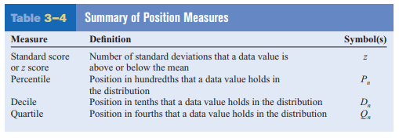
Review problems: for the data set below, find:
a. the range in which 75% of the data must fall.
b. the z-score of alligator.
c. the percentile that corresponds to the speed of the leatherback sea turtle.
d. the speed that corresponds to the 65th percentile.
e. Q1, Q2, and Q3.

Top 10 Fastest Reptiles:
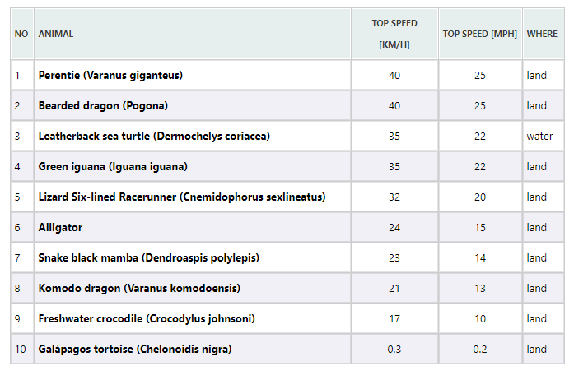
Mean (kph): 26.73
Std Dev (kph): 12.31
