Intro to Statistics Classwork/Homework Name: _________________________
Range, Variance, and Standard Deviation in Populations
Warm-up: You purchase 6 cans of Brand A paint and 6 cans of Brand B paint, and measure the fading time for each can (in months):
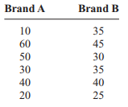
Find the mean drying time for each brand. Next time you buy paint, which brand will you choose?
In many cases, the variation in the data is as important as the center. Today we’ll define three different parameters for describing variation:
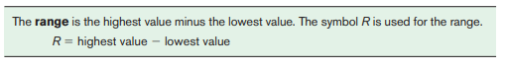
Find the range for the data for each brand in the warm-up. How does this affect your answer to the warm-up question?
How might an outlier affect the range of a data set?
Statisticians frequently use variance and standard deviation to describe variance with less sensitivity to outliers. By definition, variance is the average of the square of the distance each value in the data is from the mean. Standard deviation is the square root of variance, and therefore uses the same units as the original data. The sigma notation definitions are given below:
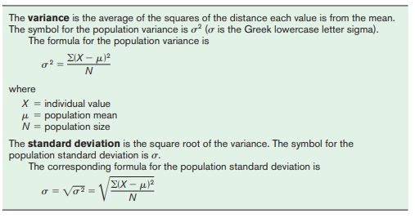
Above are the warm-up data for Brand A. Make two new columns to the right for these data, labeling one column X - µ and the other (X - µ)². Fill in both columns using the data.
Next, sum the results from the second column, (X - µ)², and divide your sum by the total number of cans of paint. What value have you found?
How should you continue in order to find standard deviation?
List the steps for finding standard deviation below:

Rounding: as with mean, you should round measures of variation to one decimal place more than the original data.
Parameters v. Samples: the procedure is different for sample variance and sample standard deviation. Only use this procedure if you have data for the full population!

Classwork/homework (you’re welcome to do this on a separate page so as to retain your notes): Find the variance and standard deviation for Brand B, presuming you are working with a population. Then solve problem 16 below:

