Intro to Statistics Classwork/Homework Name: _________________________
Introduction to Percentiles: Formula
Warm-up: How many percentiles are there?

Percentiles
Like a z score, a percentile is a measure of position. However, percentiles are calculated somewhat differently.
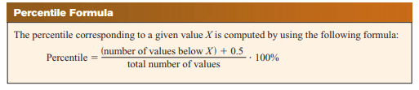
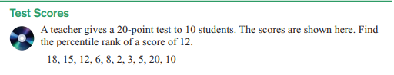
1. Find the percentile rank of a score of 6.

2. Substitute the letters p, n, and c for the Percentile, total number of values, and number of values below X, respectively, in the formula for percentile. Cross out the 0.5, and then solve for c.

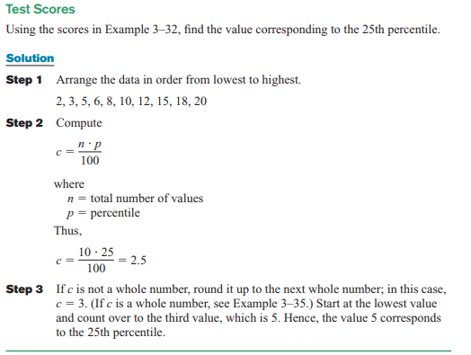
3. Find the value that corresponds to the 60th percentile. (In step 3, you’ll need to find the value halfway between c and c + 1.)

Classwork/homework (you’re welcome to do this on a separate page so as to have enough space and retain your notes): #22, 23, 28, 29.
