Intro to Statistics Classwork/Homework Name: _________________________
Histograms, Frequency Polygons, and Ogives
Warm-up: brainstorm shapes you might see in a histogram or frequency polygon. (You might want to look at the shapes you created for homework.)

Homework Review: any questions?
Distribution Shapes
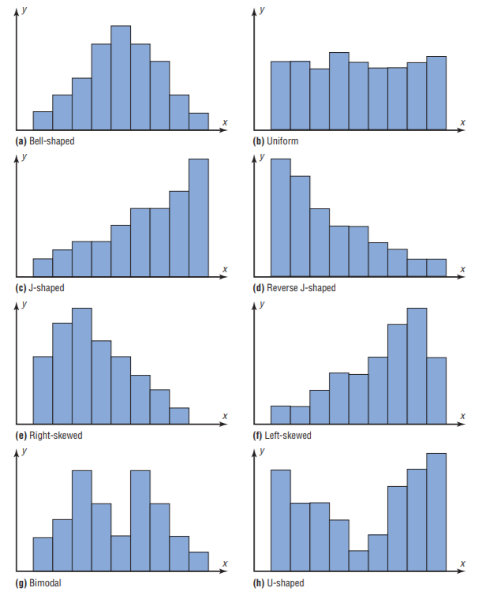
Which of these shapes has only a single peak? What term might apply to these?
Which of these shapes is “skewed” to the left or to the right? What does it mean to be skewed?
Will these shapes apply to an ogive?
What is the term for a datum that lies to the far left or far right of a distribution and does not fit the general shape?
Practice: as a class, we will construct an ogive for the data in problem 1 below.

Classwork/homework: Create a histogram AND an ogive of the data in ONE of the problems below: #2, 3 or 7. Label the shape of the histogram you constructed.
