Warm-up:
In groups, discuss what kind of survey you chose to do as the Family Research Council in the homework scenario. Did you all choose the same type? Do you agree with each other’s logic?
Homework Review:
- One representative from your table should present any question your table found challenging.
Observational and Experimental (and Quasi-Experimental) Studies
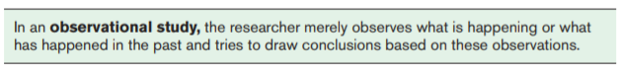
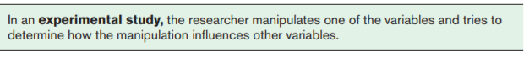
What might make a study quasi-experimental?

Why might a researcher be unable to complete an experimental study?

More about variables:
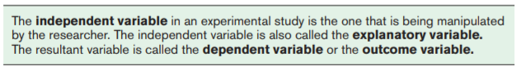
What does it mean to do a controlled experiment?

Measurement Scales for Variables
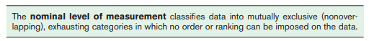
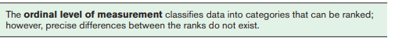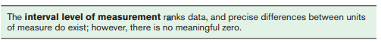
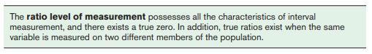
To the right of each level of measurement, identify whether the variables at this level are quantitative or qualitative and discrete or continuous and give ONE example of each level of measurement.

Exit Ticket: Identify the type and subtype of ONE variable from our class data set, and the level of measurement for that variable. (The variables are listed on the board.)
Classwork/Homework:
Reread the studies below.
- To the right of the text, record whether each study is experimental or observational.
- Next, circle the variables in each study. To the right of the text, identify the dependent and independent variables and the level of measurement used for each.
