Intro to Statistics Classwork/Homework Name: _________________________
More Graphs
Warm-up: what type of graph might you use to represent the number of times different schools have won a specific sports championship?
- Construct a frequency distribution for the data below. Then use that to build the Pareto chart and vertical bar graph.
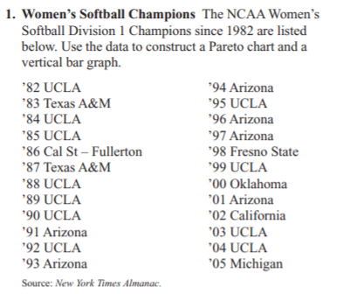
- Use the data below, of Presidents’ Ages at Inauguration, to build (a) a frequency distribution with 7 classes; (b) a histogram; (c) an ogive; and (d) another graph appropriate to these data. NB: Data are in chronological order going down each column. Since this table was constructed, three further presidents have served full or partial terms. Their ages at inauguration were: 54, 47, and 70.
You should not construct a stem and leaf plot.
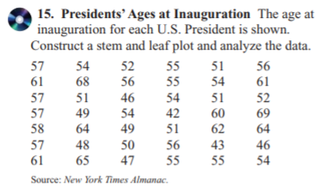

How-to: Bar Graph
Pareto Chart
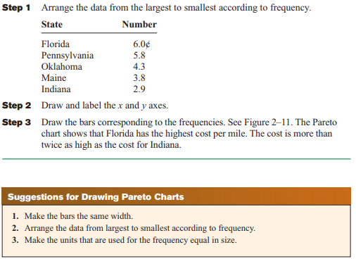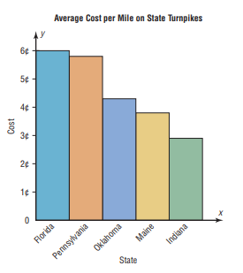
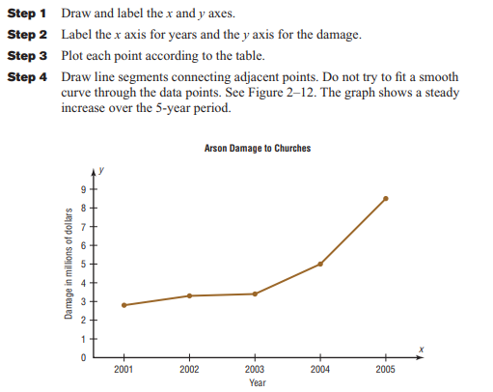
Time Series
Pie Chart
