Intro to Statistics Classwork/Homework Name: _________________________
Measures of Central Tendency: Mean, Median, and Mode
Warm-up: sort the data below in order from lowest to highest value for each column:
Happiness (1-10) | Excitement (1-10) | Distance from School (mi) | OLDEST age (yrs) | YOUNGEST age (mo)
9 | 10 | 2.54 | 84 | 5
10 | 10 | 3 | 93 | 8
6 | 7 | 3 | 101 | 2
4 | 4 | 10 | 82 | 10
8 | 6 | 10 | 94 | 2
2.5 | 7.3 | 3 | 103 | couple month
8 | 5 | 10 | 89 | 2
2 | 2 | 10 | 93 | 10
1 | 1 | 10 | 89 | 2
1 | 1 | 15 | 99 | 12 months
8 | 5 | 7 | 89 | 2
-45 | -2 | 2 | 95 | 2
8 | 3 | 1 | 70 | 5
4 | 4 | 3 | 90 | couple months
1 | 1 | 15 | 102 | 8
4 | 2 | 5 | 99 | 2 Weeks
4 | 9 | 2 | 86 | 11
2 | 1 | 15 | 76 | 2 years
5 | 2 | 5 | 86 | 5
4 | 2 | 5 | 103 | 2 Weeks
Mean:
Median:
Mode:

Do you remember “mean, median, and mode?” Notes:
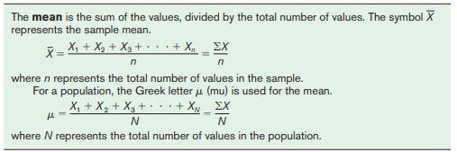
Classwork/homework (you’re welcome to do this on a separate page so as to retain your notes):
1. Find the mean, median, and mode for each of the variables in the class data set.
2. Answer the questions about salary below:
