Intro to Statistics Classwork/Homework Name: _________________________
Introduction to Z Scores
Warm-up: You took the SAT in 2018, and you’ve just learned that you got exactly the same score on the reading section of the SAT that your older sibling/friend did when s/he took the test in 2013. (Don’t worry, you both did really well!) Which of you should be more proud of your score? Why?
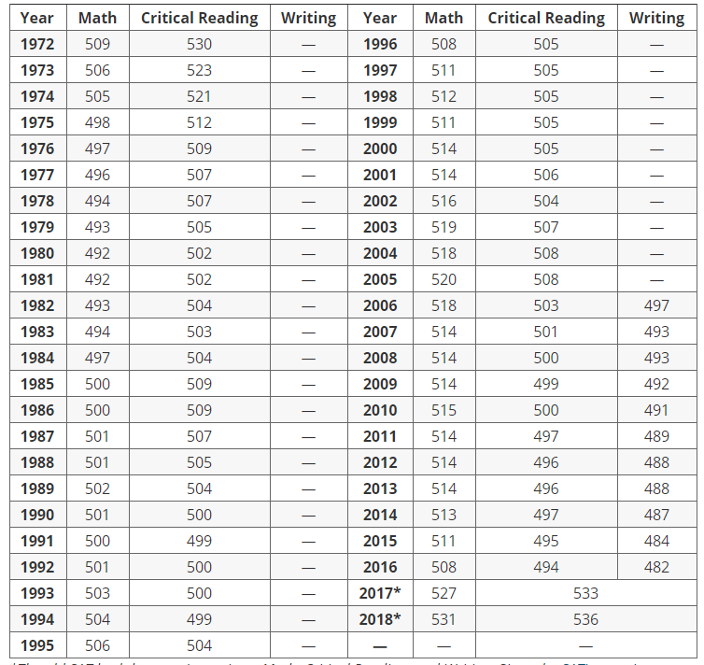
Measures of Position
Frequently we will want to discuss one datum from a data set and describe where it falls among the data. There are a number of ways to do this. One is the z score.
Z Scores
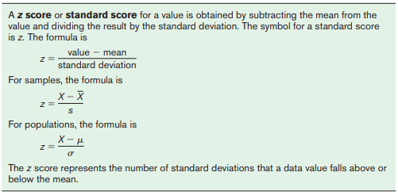

2018
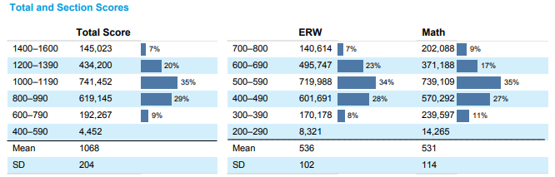
2013
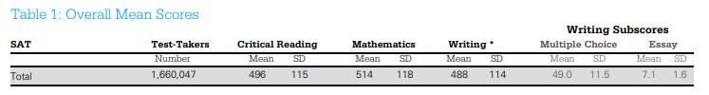
Calculate the z score for a student who earned a score of 760 on the ERW section in 2013, and for a student who earned a score of 760 on the ERW section in 2018.

Now let’s compare how one student is doing in two different classes:
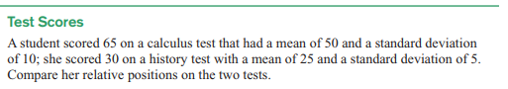

Classwork/homework (you’re welcome to do this on a separate page so as to have enough space and retain your notes): #10, 11, 13-15
