Intro to Statistics Classwork/Homework Name: _________________________
Introduction to Percentiles: Graphs
Warm-up: What is the highest percentile rank?
Percentiles
Like a z score, a percentile is a measure of position. However, percentiles are calculated somewhat differently.
A student with a total scaled score of 660 on the TOEFL in 1990 scored better than _____ of students who took the exam.
A student with a total scaled score of 520 on the TOEFL in 1990 scored better than _____ of students who took the exam.
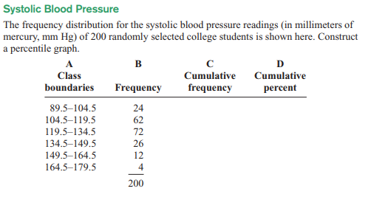
Using your percentile graph, answer the following questions:
1. What value corresponds to the 40th percentile?
2. What percentile corresponds to a blood pressure of 130 mm Hg?

Classwork/homework (you’re welcome to do this on a separate page so as to have enough space and retain your notes): #16, 17, 20, 21.
