Intro to Statistics Classwork/Homework Name: _________________________
Introduction to Chebyshev’s Theorem
Chebyshev’s Theorem
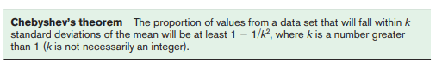
According to Chebyshev, what percentage of values will fall within 2 standard deviations of the mean? Within 3 standard deviations?
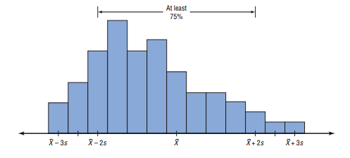
Update the graph to indicate the percentage of values that will fall within 3 standard deviations of the mean.

What shapes of distribution must you have to use Chebyshev’s Theorem?

The Empirical (Normal) Rule

A bell-shaped distribution is called “normal” in statistics. The empirical rule states that for a normal distribution:
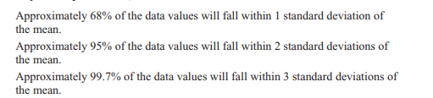8
Make a graph to visualize this!

Classwork/homework (you’re welcome to do this on a separate page so as to retain your notes):
