Intro to Statistics Classwork/Homework Name: _________________________
Histograms, Frequency Polygons, and Ogives
Warm-up: Find the class midpoints from the net worth grouped frequency distribution on your classwork/homework from last class. You can do this by adding the class limits, then dividing by 2.

Homework Review: any questions?
Histograms and Frequency Polygons
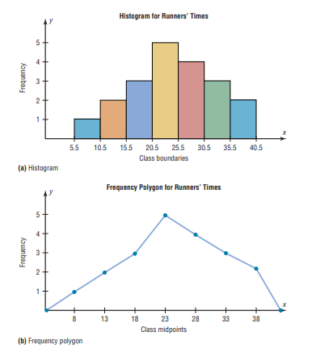
To the right of the graphs above, construct the frequency distribution that generated the graph. How would you make one of these graphs from a frequency distribution?
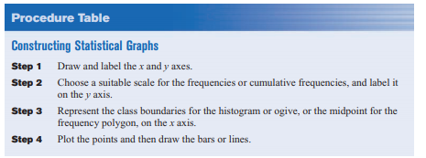

Cumulative Frequency Distributions
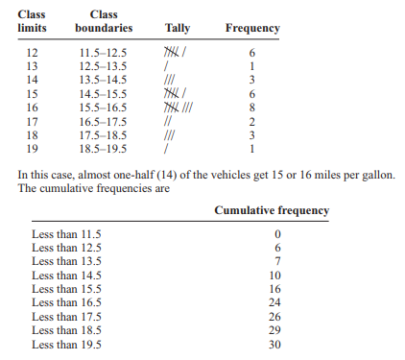
A cumulative frequency distribution is a distribution that shows the number of data values less than or equal to a specific value (usually an upper boundary).
The frequency distributions shown here are for the same data, mileage for SUVs. What can you see more clearly from the cumulative frequency distribution than from the ungrouped frequency distribution?

Ogives
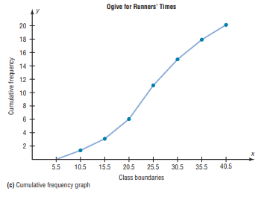
An ogive is the graph form of a cumulative frequency distribution.
How would you obtain the cumulative frequency for each class boundary?

Classwork/homework: Construct a histogram and a frequency polygon for ONE of the frequency distributions you made in class in the last few days.
Exit ticket: Can you make a histogram with categorical data?

