Intro to Statistics Classwork/Homework Name: _________________________
More Graphs
Warm-up: brainstorm types of graphs you commonly see in articles or summaries of real data.
Homework Review: any questions?
Definitions
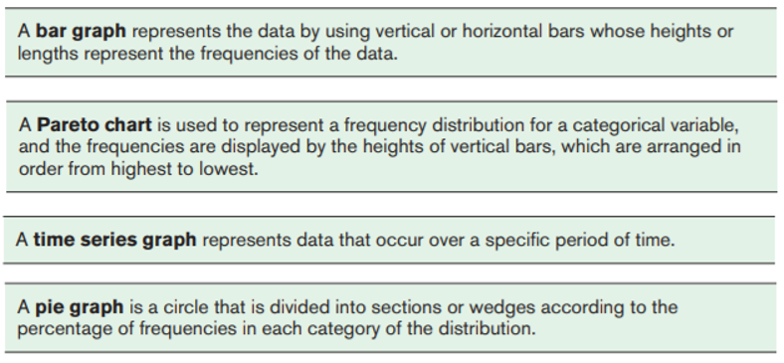
What type of data do you need for each type of graph?
Below are some data about CSD Varsity Football from MaxPreps.
Identify a type of graph you might use for each type of data.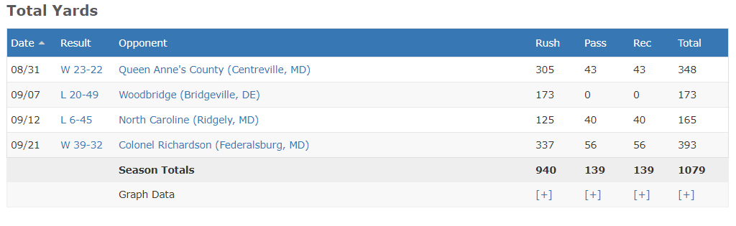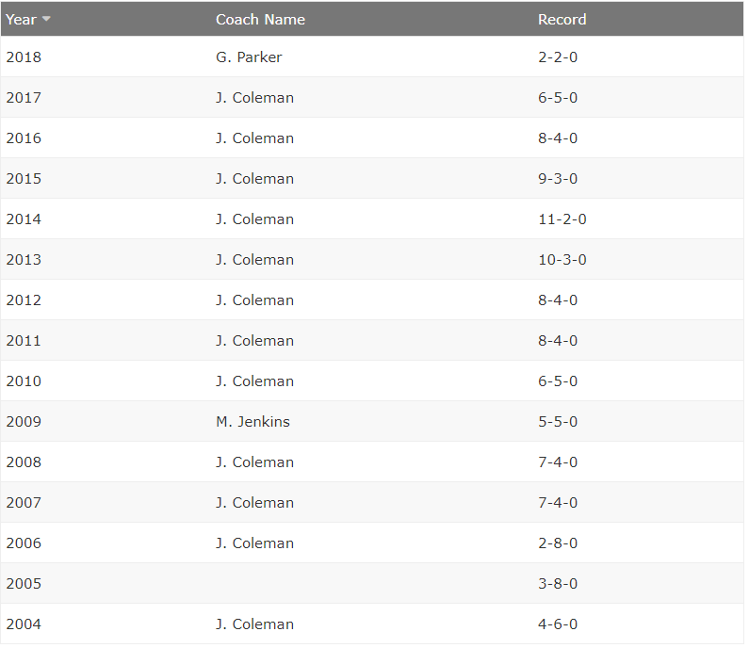
Below are the Dorchester County results for the 2016 presidential election, courtesy of elections.maryland.gov
Identify a type of graph you might use for these data.
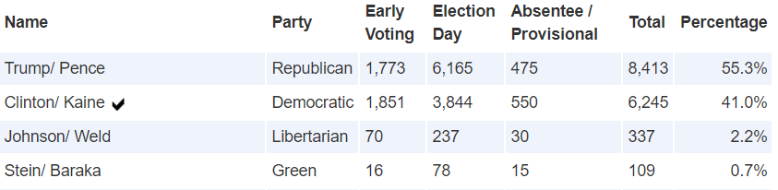
Let’s make a time series with some of these data:

Now let’s make a bar graph:

Classwork/homework:
