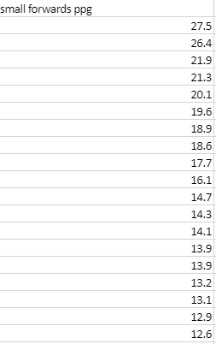
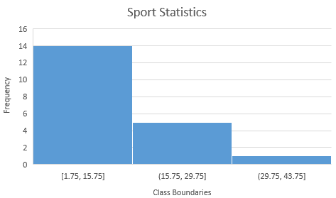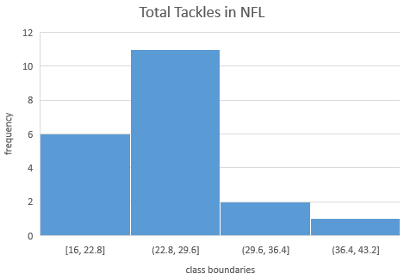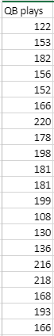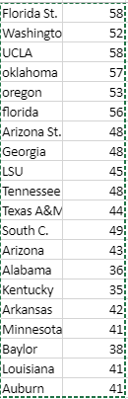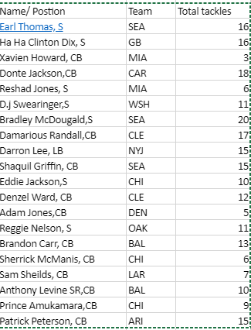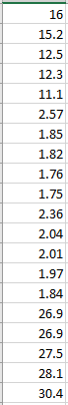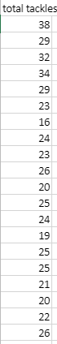

- Create a frequency distribution for your first data set (or, if yours is not reproduced above, choose one) with 5 classes:

- Create a pie chart for the frequency distribution you made above:

- What are advantages and disadvantages to using Excel to make a histogram?

- What are advantages and disadvantages to using Excel to make a pie chart?

- How do you insert any graph in Excel?

