Homework on Descriptive and Inferential Stats and Variable Types
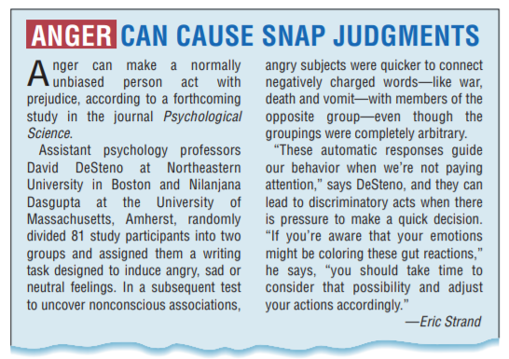
- Read the two articles above. Underline the sample. To the right of the text, record the population this sample represents in the conclusions drawn in the study.
- Next, circle the variables in each study. To the right of the text, record the type of variable and what level of measurement was used for each variable.
- What type of statistics are the researchers performing in the first study? Explain your answer:

- What type of statistics are the researchers performing in the second study? Explain your answer:

- Do you think the conclusions the researchers reach in the first study are reasonable? What questions might you ask these researchers to be convinced?

- Do you think the conclusions the researchers reach in the second study are reasonable? What questions might you ask these researchers to be convinced?

