Intro to Statistics Classwork/Homework Name: _________________________
Deciles and Quartiles
Warm-up: What does the prefix “dec-“ mean? What about “quart-“?

Deciles
Like a z score or a percentile, a decile is a measure of position. Deciles and quartiles can be calculated much like percentiles. Change the definitions below to apply to deciles.
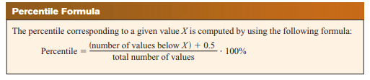
The first decile corresponds to the ______ percentile.
Quartiles
How many equal groups do quartiles create? Draw a box to represent your data and partition it into the correct number of points.

The first quartile corresponds to the _______ percentile.
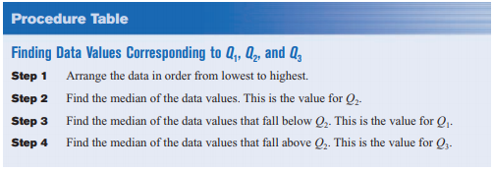
Divide the test score data from our percentiles lesson (reproduced below) into deciles.
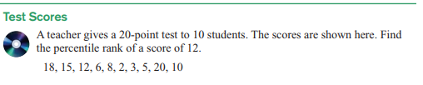
Now divide the test score data into quartiles.
Classwork/homework (you’re welcome to do this on a separate page so as to have enough space and retain your notes): For the problems below, find:
a. The 35th percentile
b. The 3rd decile
c. The first, second, and third quartile

