Warm-up:
In groups, discuss a survey you or your groupmates can remember filling out. This can be a survey for school; a survey for a business you patronized; or any other survey you can recall. Choose one representative to answer questions about this survey.

Homework Review:
- In your table group, discuss your answers to the homework questions about the SECOND study.
- One representative from your table should present any question your table found challenging.

Types of Surveys and Data Collection (Discuss Pros and Cons of each)
Type | Pros | Cons
Telephone
Mail
Personal Interview
Direct Observation
Review of Records

Sampling and Bias: What’s wrong with the survey technique below?
CSD puts a link to an anonymous survey on its webpage. The anonymous survey is completely voluntary and asks students to rate the new cell phone policy on a scale of 1-5, with 5 being strongly in favor and 1 being strongly opposed.
Bias:
Sampling methods to avoid bias:
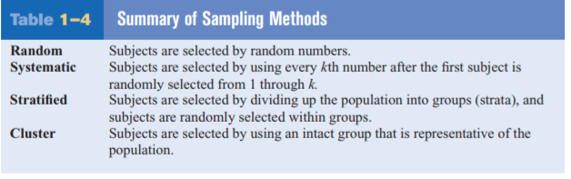
Closure: In your groups, answer the following question on your white board:
Suppose the president of a two-year college wants to learn how students feel about a certain issue. Furthermore, the president wishes to see if the opinions of the first-year students differ from those of the second-year students. What type of sampling should the president use?

Classwork/Homework:
