Intro to Statistics Classwork/Homework Name: _________________________
Coefficient of Variation and the Range Rule of Thumb
Warm-up: Which had more variation in your project data: hours slept on week nights or hours slept on weekends? What about hours slept on weeknights v. number of texts?
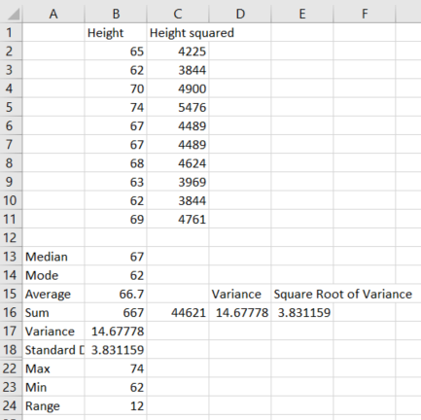

Coefficient of Variation
Sometimes you will want to compare data sets that used different units, such as the number of sales per salesperson and the commissions made by the same salespeople, to determine which data have more variation. However, standard deviation has the units of the data set. To compare data with different units, we will use the coefficient of variation.
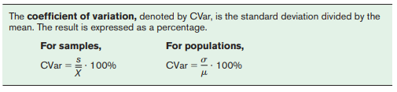
Try it:
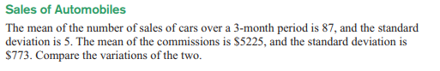

Range Rule of Thumb
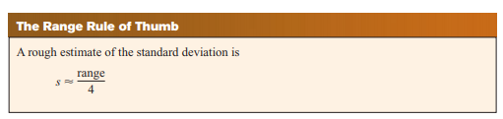
If your data are unimodal and roughly symmetric, the range rule of thumb can be used to estimate the standard deviation quickly. This is especially useful in checking your work. Does it work for the height data?

Classwork/homework (you’re welcome to do this on a separate page so as to retain your notes): Solve problems 12, 13, 30, and 31:
