Intro to Stats Practice Name: ________________________
Applications of Chebyshev’s Theorem Date: _________________________

Do problems 32, 33, and 35-40 below. CHALLENGE: try 34, 41, or 42.

Some helpful formulas:
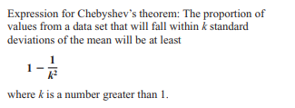
The lower bound of a range obtained using Chebyshev’s Theorem is
$$\overline{X}-ks$$
where $\overline{X}$ is the mean, s is the standard deviation, and k is a number greater than 1.

