Intro to Statistics Classwork/Homework Name: _________________________
Measures of Central Tendency in Grouped Data
Warm-up: If four people bought gas for $2.65 a gallon at Crown, ten people bought gas for $2.69 a gallon at the Wawa, and two people bought gas for $2.79 at the Exxon, what is the average price those people paid per gallon?
Mean in grouped data:
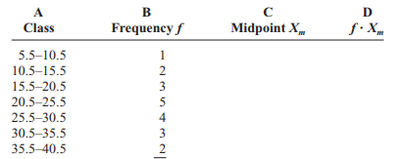
Step 1: Make a table
Step 2: Find the midpoints for each class
Step 3: Multiply the frequency times the midpoint for each class
Step 4: Sum the weighted midpoints
Step 5: Divide the sum by the number of data points

Should this give you the exact mean for the original data?
Mode in grouped data:
The modal class is the class with the largest frequency. Identify the modal class, if any, in the frequency table above.
Weighted Mean
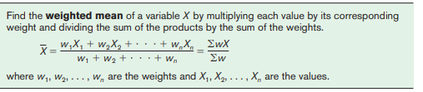
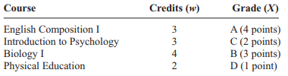
Find the GPA of the student whose report card is shown above. Each grade should be weighted by the number of credits that course is worth.
Midrange
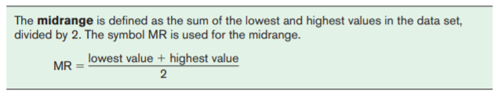
Find the midrange for the gasoline data from the warmup.
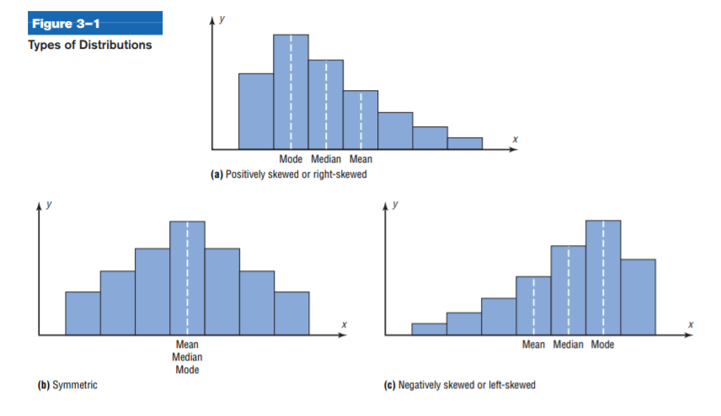
Distribution Shapes Again
When the data are skew, the mean is pulled towards the tail, so the median is a more appropriate measure of central tendency.

Exit Ticket: There are eight formative and three summative assignments in a CSD class. Each assignment is worth 100 points. One student has scores of 100, 100, 90, 100, 100, 0, 100, 50 on the formatives, and 95, 87, and 100 on the summatives. What is the student’s current grade in the class?

Classwork/homework (you’re welcome to do this on a separate page so as to retain your notes): #12-14, 27-30

