Intro to Statistics Classwork/Homework Name: _________________________
Box Plots
Warm-up: Find the quartiles for the data below:
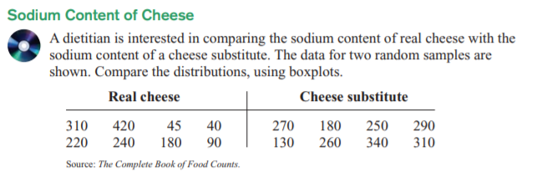
Box Plots
A box plot visualizes the center and spread of a data set. Since it relies on quartiles, rather than on the mean, it is more appropriate for visualizing data that contain outliers than an analysis that would use the mean and standard deviation.
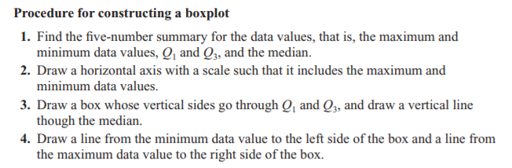
Construct a box plot for each of the two types of cheese from the warm-up:

Some Vocabulary
Interquartile range:
Outlier:

Classwork/homework (you’re welcome to do this on a separate page so as to have enough space and retain your notes): Construct a box plot for each ODD problem below:

