Intro to Statistics Project – due Thurs 12/20 Name: __________________
Data Comparison with Plots Date: ___________________

For this project, you will answer the attached prompt as though you were an insurance underwriter. You may choose which plots and summary statistics to use, but your memo MUST include plots. There are some hints for how to construct different types of plots and how to use the TI-84 to help on this page. Below is a table of different plots and statistics you might use to describe the data. EDA stands for Exploratory Data Analysis, and is more resistant to outliers.
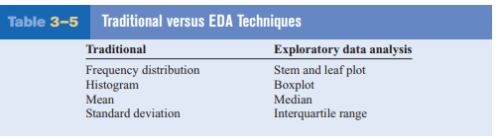

Summary Statistics using the TI-84
The TI-84 will calculate the mean, sum, sum of squares, sample and population standard deviations, smallest data value, lower quartile, median, upper quartile, and largest data value from a table. Here’s how to use this functionality:
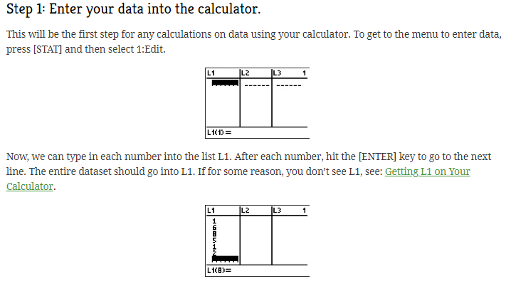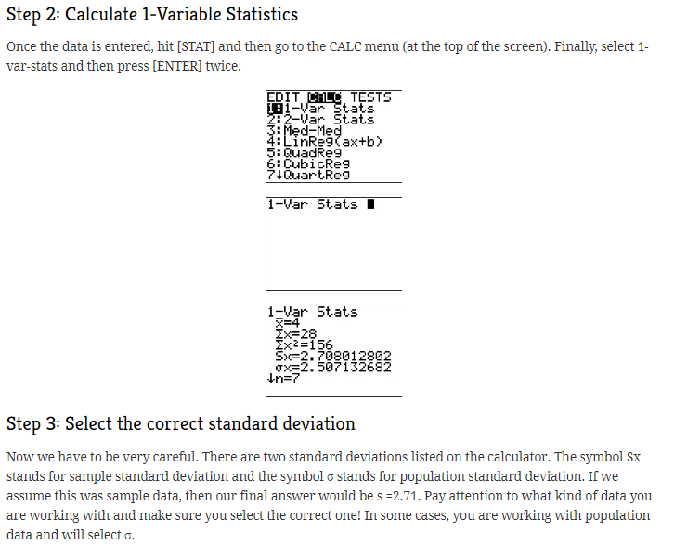
Stem-and-Leaf Plots
The leaf is frequently the last digit.
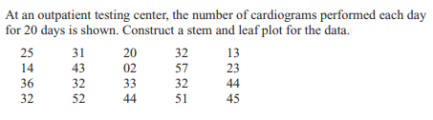
Boxplots
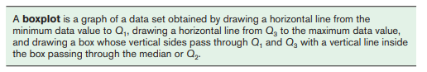
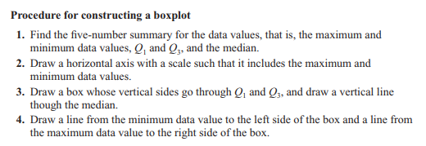

Identifying Outliers
